**Initial setup:**

Before we start using the application, we have to make sure that the connection to the server is enabled. For that, the following have to be done:

1. Search for the “localhost” name in the connection files.
2. Change the name from “localhost” to the server that is been connected.
3. If the server contains any username and password, mention those in the username and password field in the connection files respectively.
4. After the connection files are set, type “<servername>/ProjectProfitability” to start the application.
5. And also change the database name to the database that is been used and import the SQL file into the connected database.

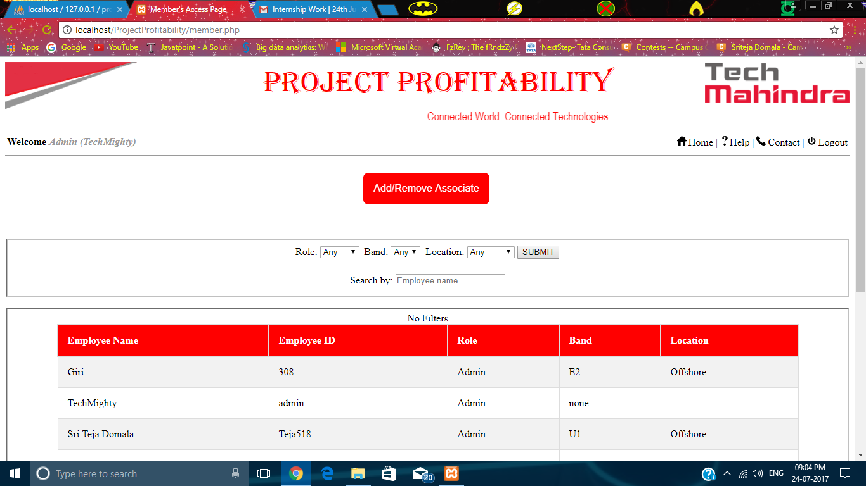**Fig: (i) Page with details of members who have access**

The above page consists of details of members who can access to the application. This page opens with the link “**View accessible members**” from the Admin’s dashboard. In this page, members can be filtered according to Role/Band/Location or with combination. And also an employee can be searched by typing the employee’s name in the search bar.

When the name of the user after the welcome text is clicked, the profile page of the current user will be opened.

Login:

The first page which appears after opening the web application is the login page without the credentials(Username and password) you cannot access the application after login there are dashboards depending on the associates.

To login user requires username and password which will be provided by the admin after that associate can change the password. When user enters the credentials it cross checks with the database and then an alert will be displayed on the top of the page with message that login is successful

Below is the sample screenshot of the login page.

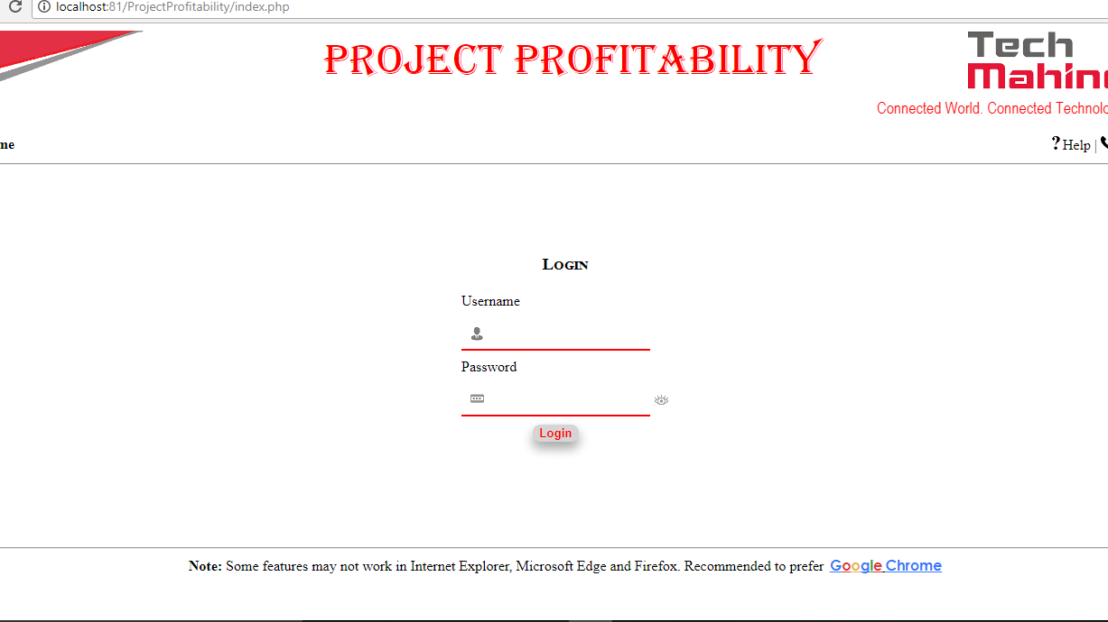

If login is successful then message will be displayed as shown in the fig below. After that it redirects to the dashboard depending on the username.

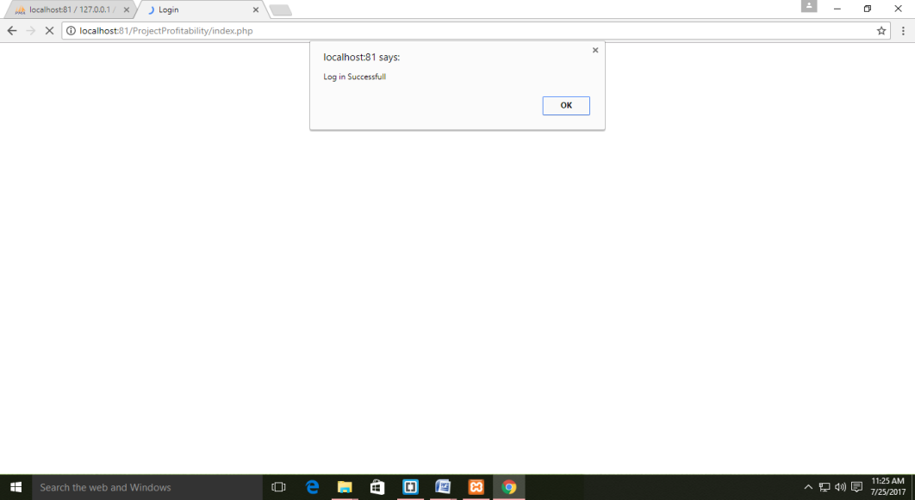

If any of the credentials doesn’t match like either username or password are wrong then it displays an alert with message that your credentials are wrong.

If user forgot the password then he must contact the admin for future reference.

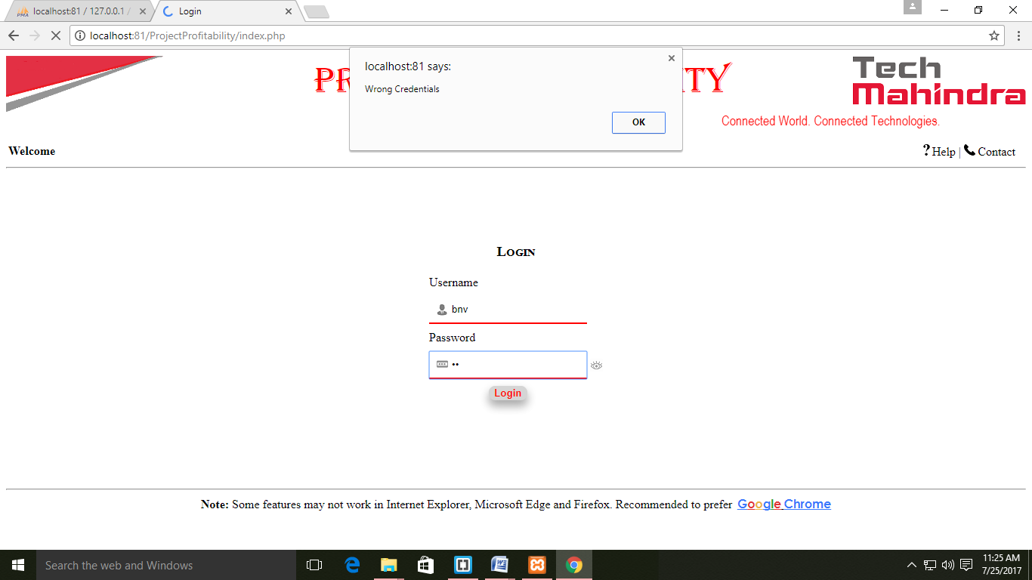

Login for new user:

Actually, admin will create the account and he will provide all the required credentials to the associate to login and when the user is using it for the first time then it asks for the password change as the password provided by the admin is default one it is must and necessary for everyone one to change the password.

So, when user tried to login (new user) with the credentials provided by the admin then it displays the alert showing you need to first change the password before you login

Below shown figure clarifies you more about the login page.

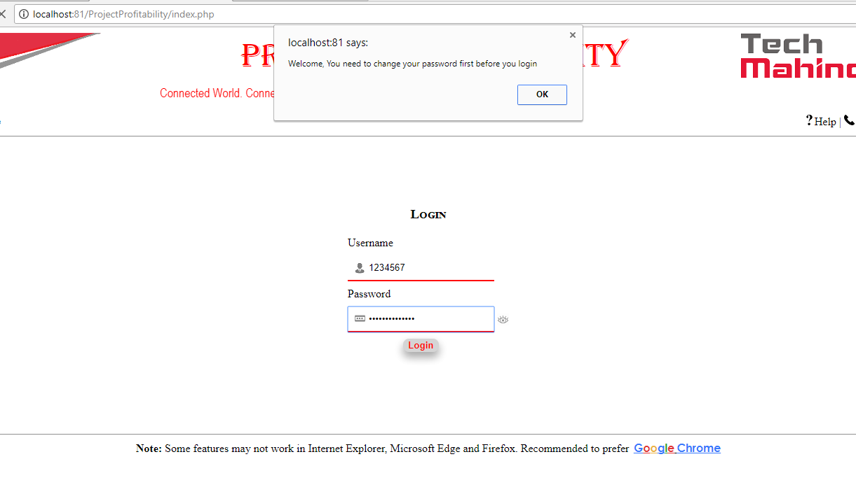

When new user tries to login then he will be directed to password change page to change the password and below shown page is the one where the user is required to enter the details of the present and new password

Also it suggests the user if the new password is weak or strong so that accordingly he can change the password.

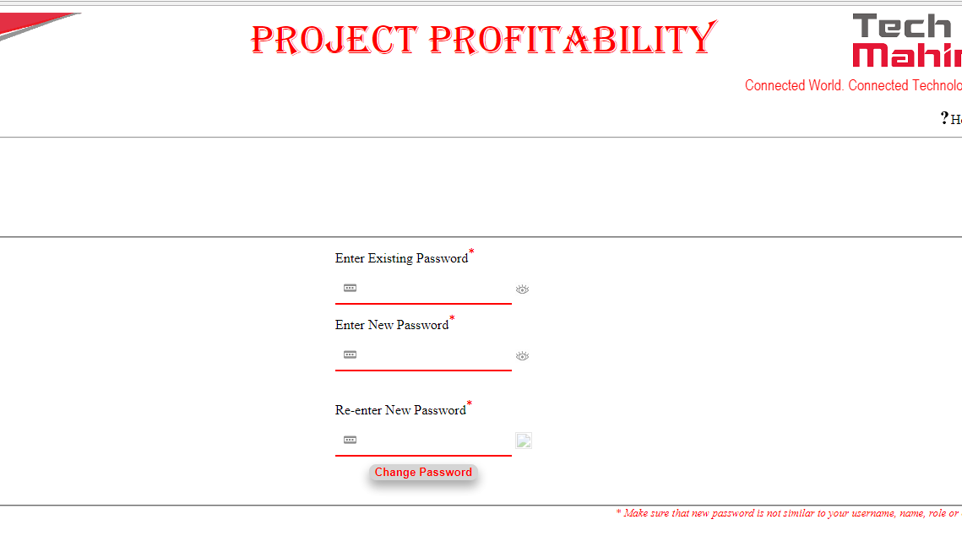

If the user enters the details correctly and then submits then alert will be displayed with a message shown.

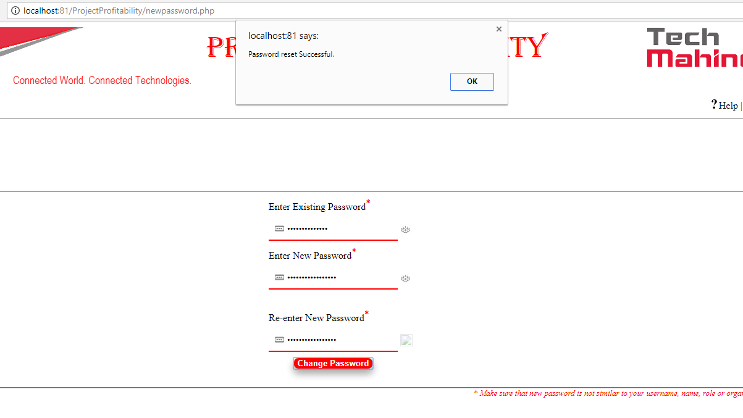

If user proceeds with the same way as discussed above then he will be redirected to profile set page, where he need to enter the personal details like first and last name, band, mobile and extension.

After the profile is set it will automatically logout from that id and login page will be displayed.

Once the profile is set now you can login directly and use the application.

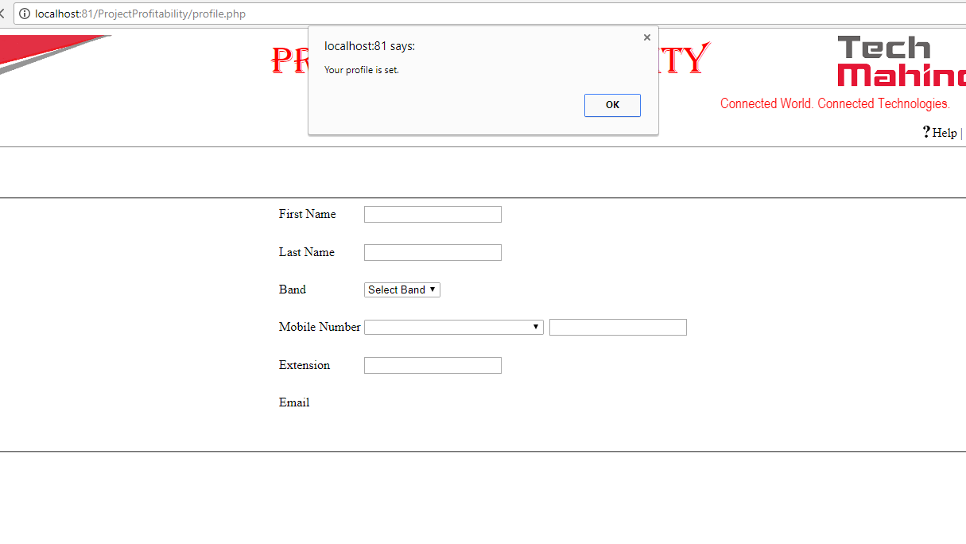

Dashboards Pages:

PM:  
When pm (project manager) logins then the user have only access to select the project and also he can see all the projects which are under him if he wants to search the project then he search the project by the project name.

In the projects he can check all the required details about the project like who are working for the project, head count for onsite and offshore (planned and actual), estimated and actual contribution. Where actually all the details will be entered either by associates above him or admin, either it may be project details or any information regarding about the project.

If the project manager wants to checks the forecast page (resources page) he can select the project and then when he clicks on the submit button then it shows the resources page.

There are other options on the top (right side) like help, contact and logout button when user have any doubt he can look at that options.

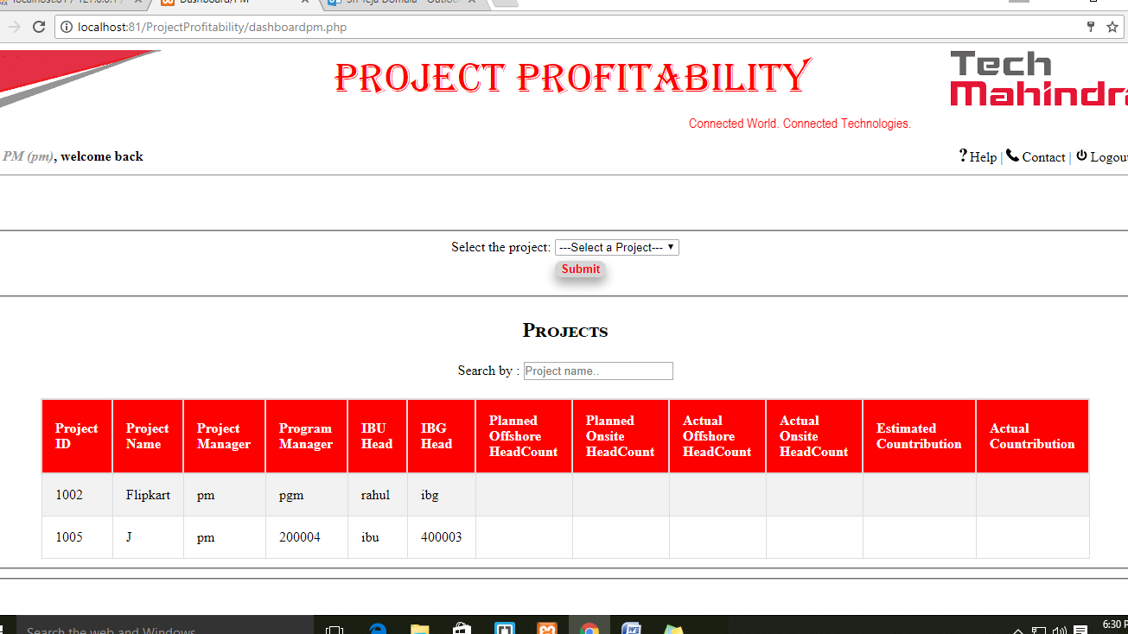

Excluding pm all other associates have the access to add the new project and enter the resources manually

PGM:

When pgm logins then he have more projects under him and also project managers working under him for that purpose he is required to select the pm and project to check the forecast page.

Program Manager also have the access to add project where pm don’t have this option when he clicks on the add project button then he will be redirected to page where user needs to enter the project details and then he can calculate the contribution.

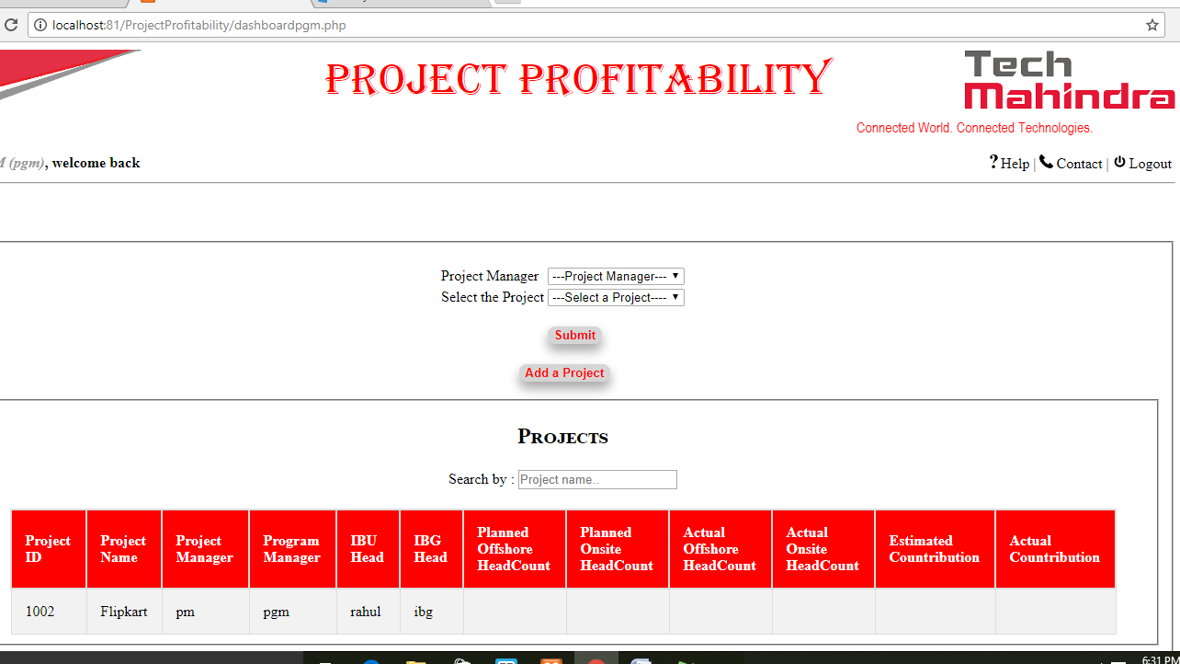

IBU:

When IBU logins then he have more projects under him and also PGM and PM working under him for that purpose he is required to select the PGM then PM and finally a project under to check the forecast page.

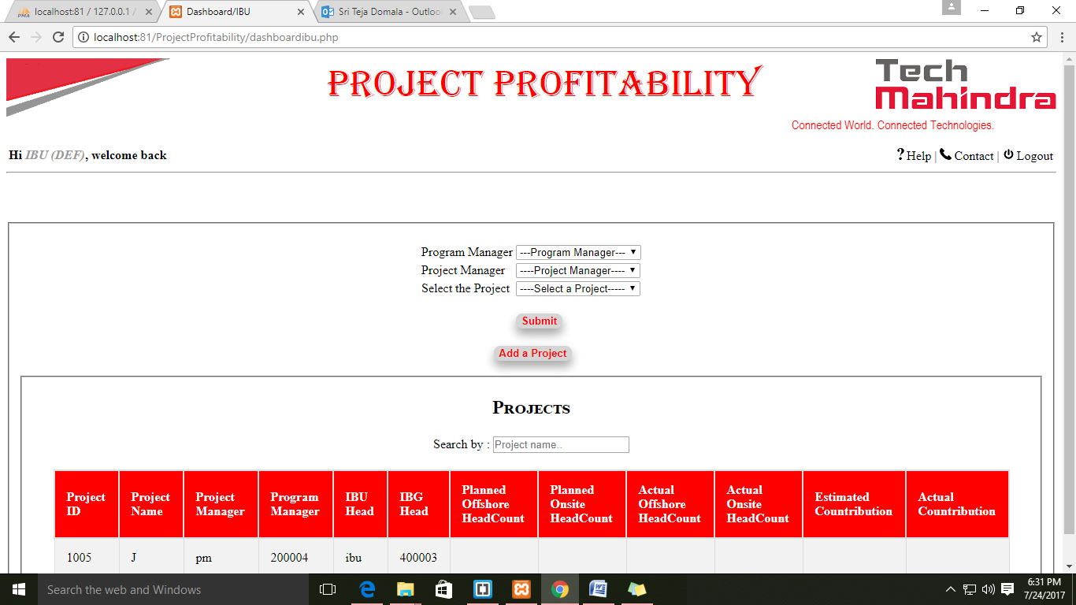

IBG:

When IBG logins then he have more projects under him and also IBU, PGM and PM working under him for that purpose he is required to select the IBU then PGM then PM and finally a project under to check the forecast page.

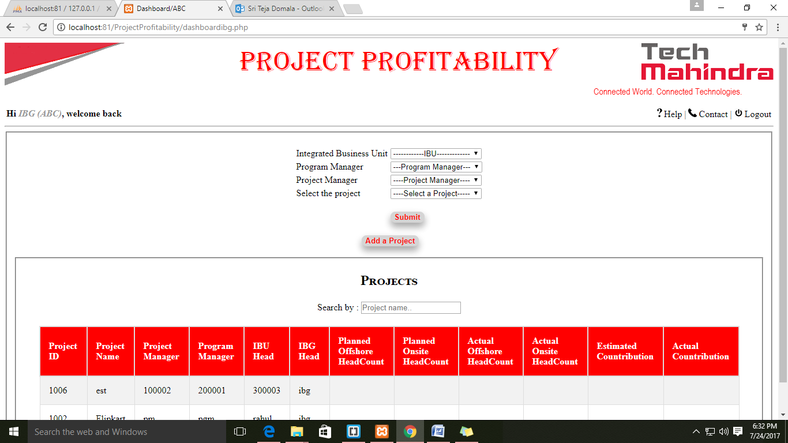

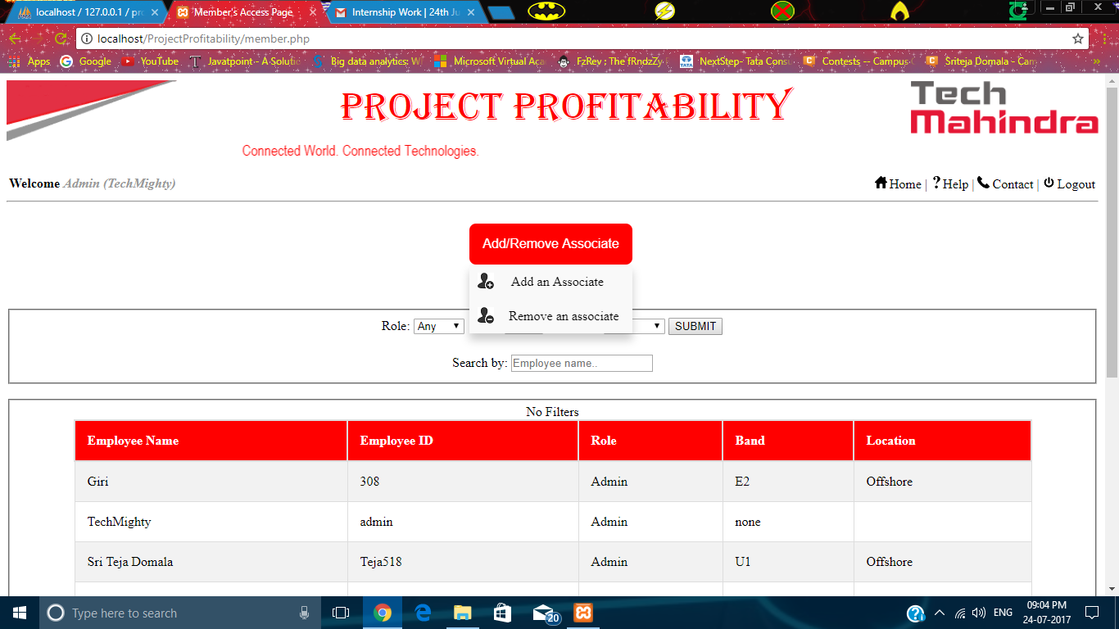**Fig: (ii) Page with details of members who have access – Add/Remove Button**

The Add/Remove button in the page is used to enable access for a new member or disable access to any existing member. When the mouse is drawn over the button, there will be a dropdown with two options “**Add a member**” and “**Remove a member**”.

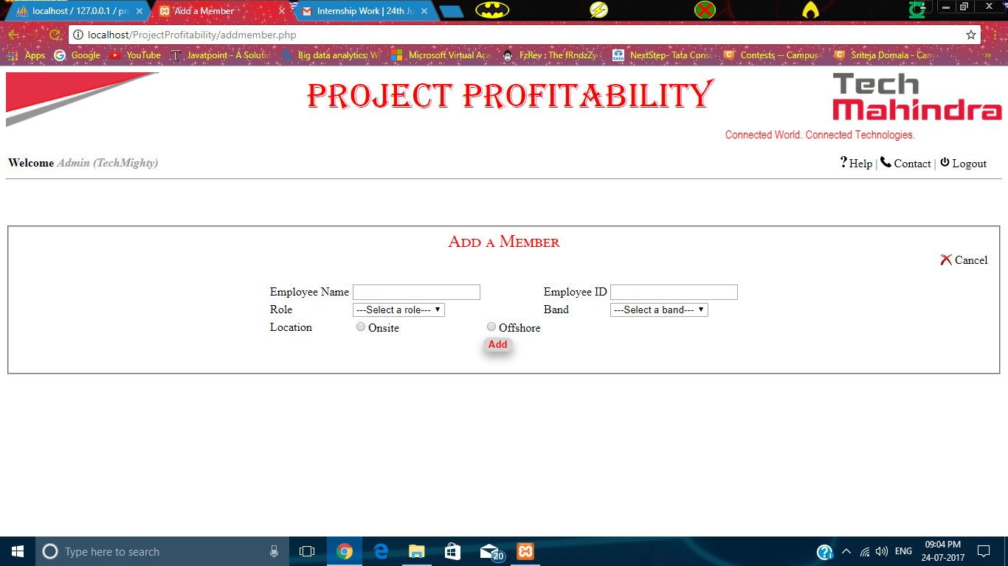**Fig: Page that adds a new member**

When the “**Add a member**” option is clicked, the above window appears. In here, the new member can be added. It can be done by entering the name of the employee, his/her ID, Role, Band and Location and then clicking the “Add” button. The cancel link on the right side of the box cancels the “Add member” process.

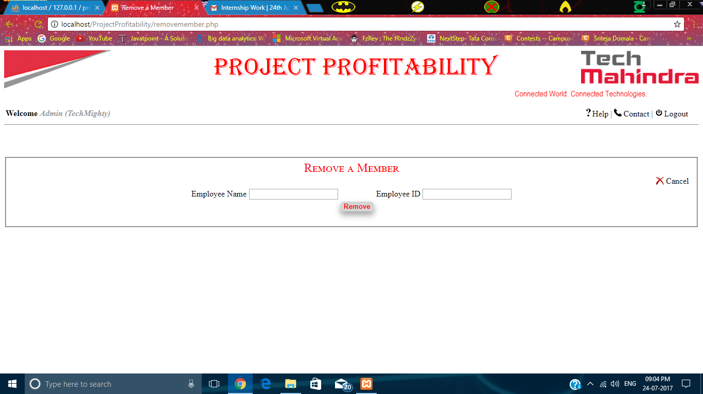**Fig: Page that removes an existing member**

When the “**Remove a member**” option is clicked, the above window appears. In here, an existing member can be removed from the accessible list. It can be done by entering the name and ID of the employee and then clicking “Remove” button.

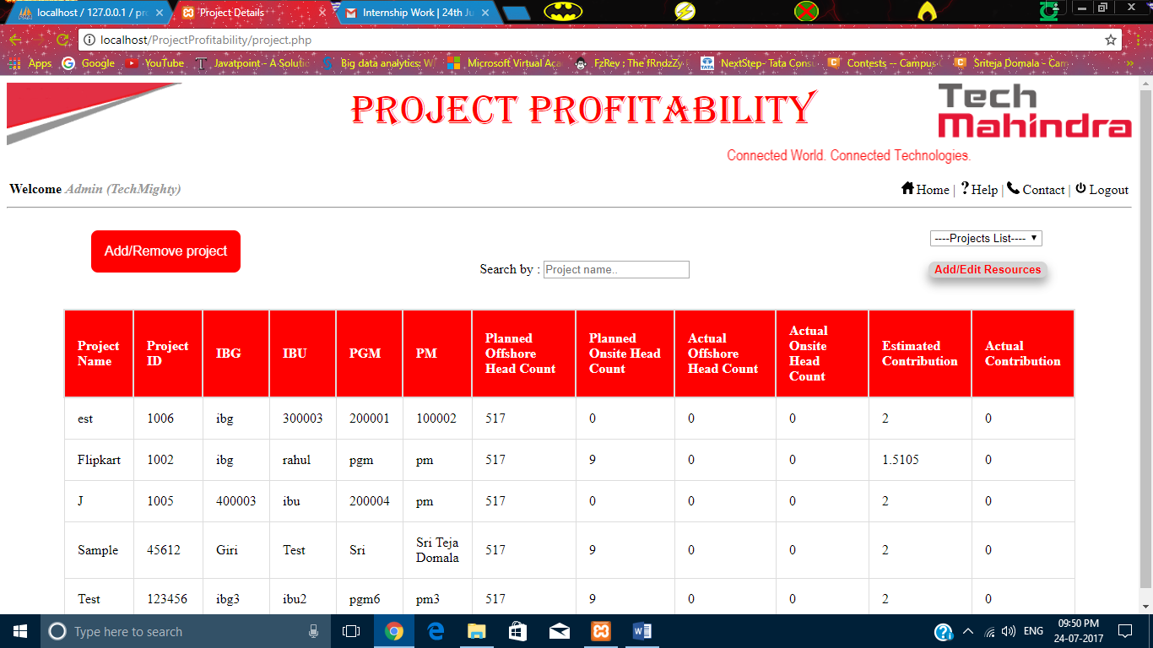**Fig: Page that displays all the projects**

The above page consists of all the projects that are added in this application. This page opens with the link “**View all Projects**” from the Admin’s dashboard. In here, a project can be searched by typing the name in the search bar. In this page, there are two other options, a dropdown with all the projects and “Add/Remove Project” option and a button displaying “Add/Edit Resources”.

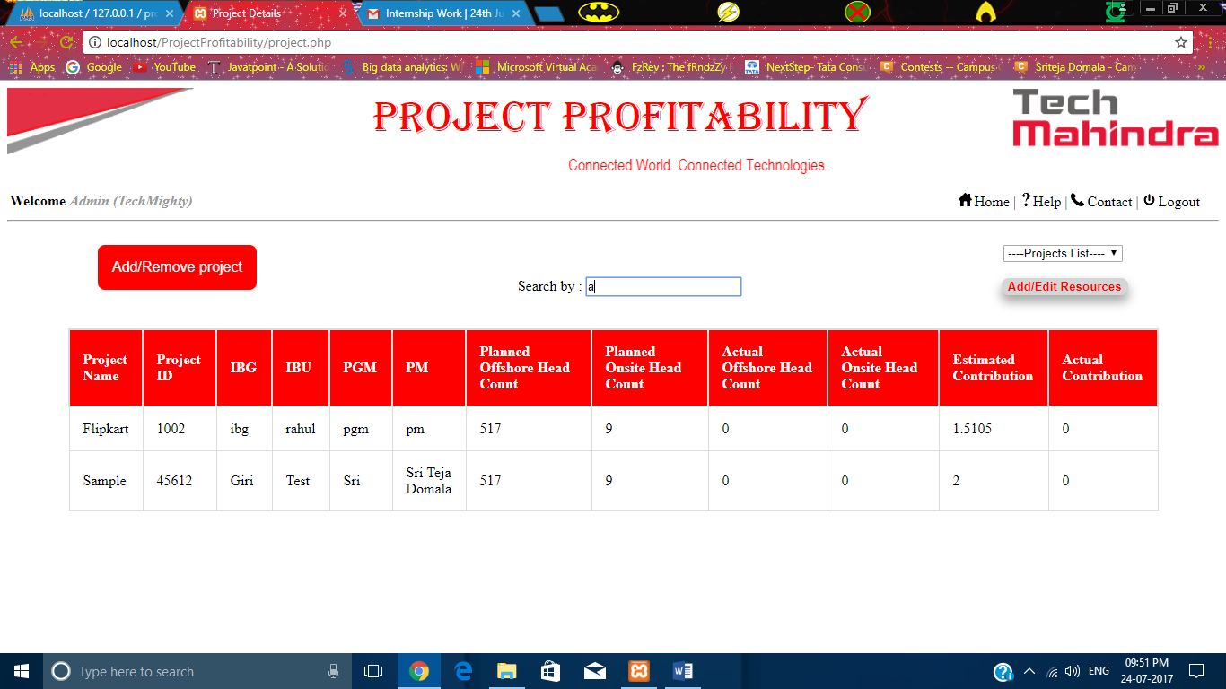 **Fig: Page that displays all the projects – Search box**

The part of the project name can also be typed in the search bar so as to get the entire details of the project you want to search.

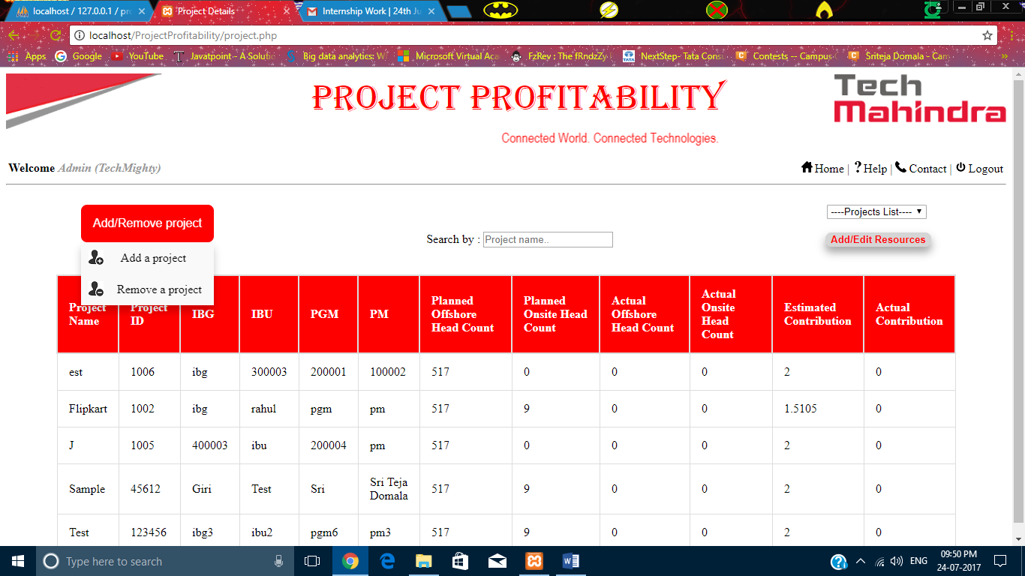**Fig: Page that displays all the projects – Add/Remove Projects**

When the mouse is drawn over the “Add/Remove Project” button, there will be a dropdown with two options “**Add a project**” and “**Remove a project**”.

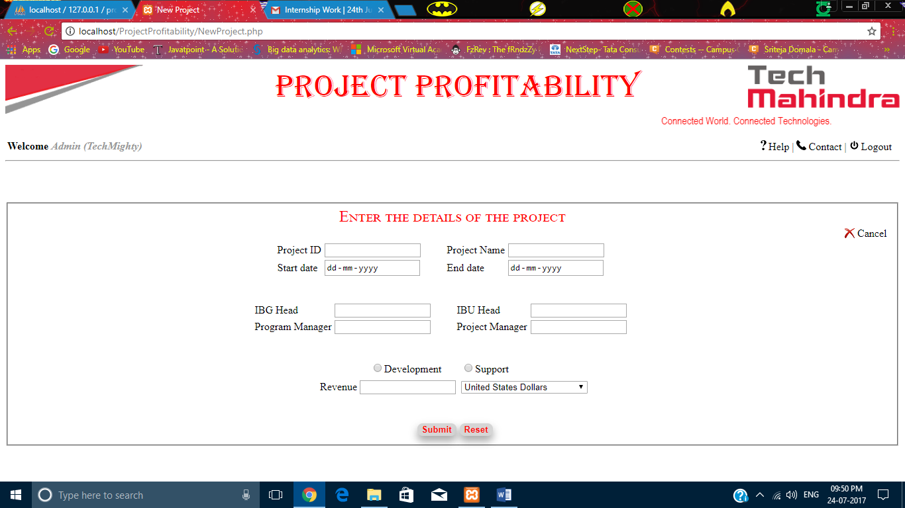**Fig: Page for adding a new project**

When the “Add a project” option is clicked, the above window appears. This page is used to add a new project into the application. It can be done by entering the Project ID, Project name, start date, end date, Integrated Business Group Head, Integrated Business Unit Head, type of the project and its revenue. And then clicking the submit button creates a project. The reset button clears all the data that is entered before entering the fields. The cancel button cancels the new project adding project.

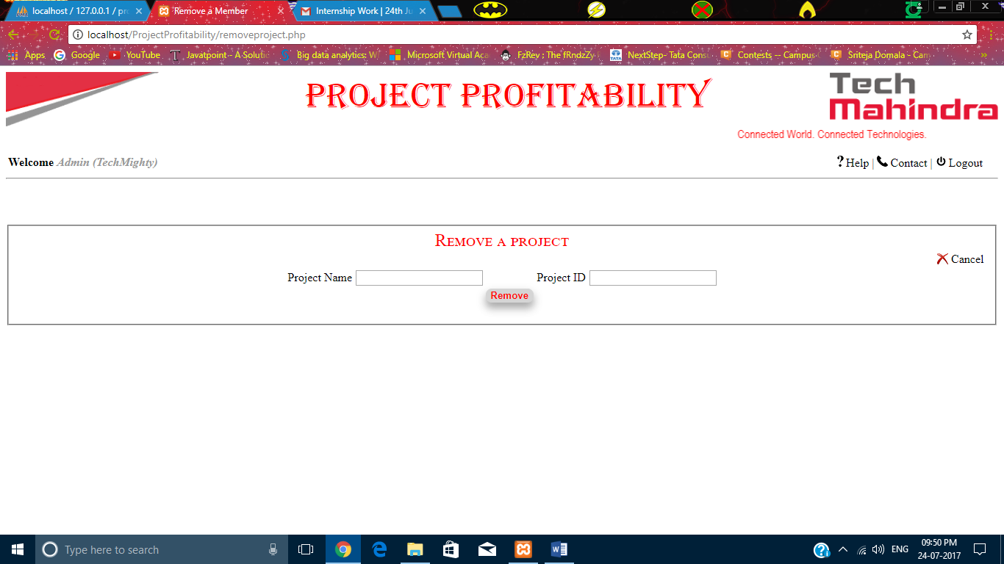**Fig: Page that removes a project**

The above page is opened when the “Remove a project” option is clicked. A project can be removed by entering the name of the project and its ID and then clicking the Remove button. The cancel button cancels the project removal project.

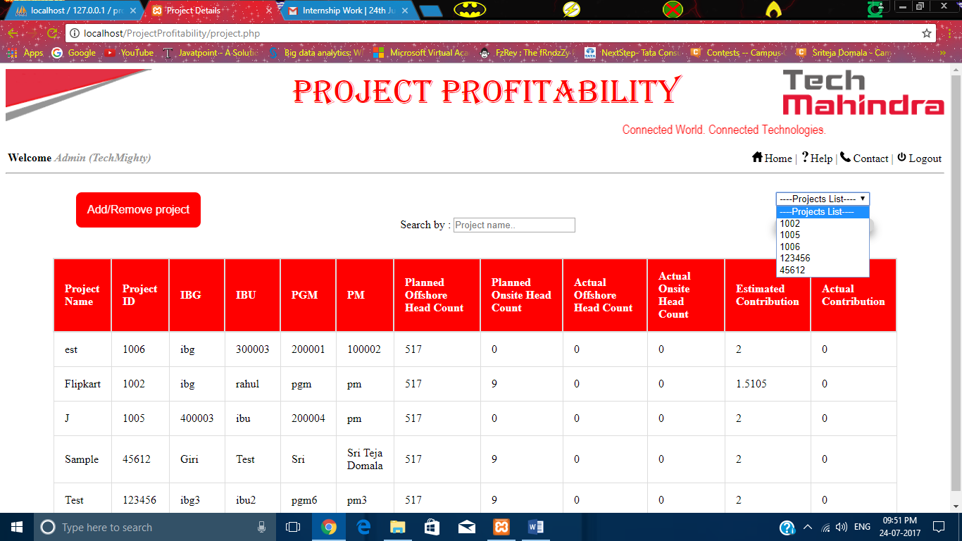**Fig: Page that displays all the projects – Dropdown**

The dropdown contains the Ids o all the projects that are displayed below in the table. After selecting a project and clicking on the “Add/Edit Resources” button, the below page appears.

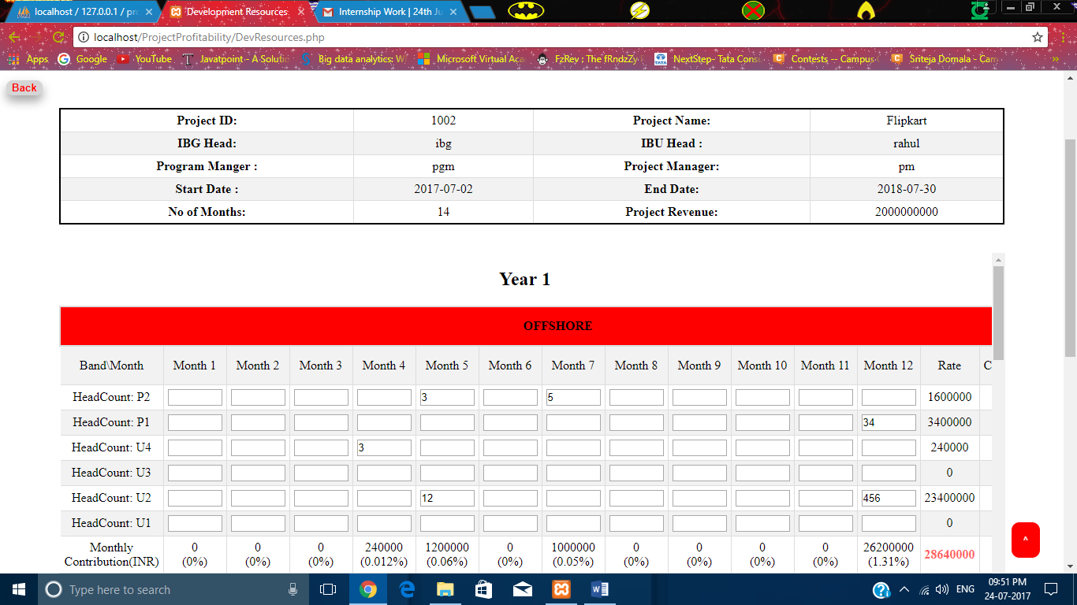**Fig: Page that adds the resources for a specific project**

This page has back button which on clicked redirects PGM, IBU Head, IBG Head to their respective dashboards and admin to the page which shows all his projects.

At the beginning, the page displays,

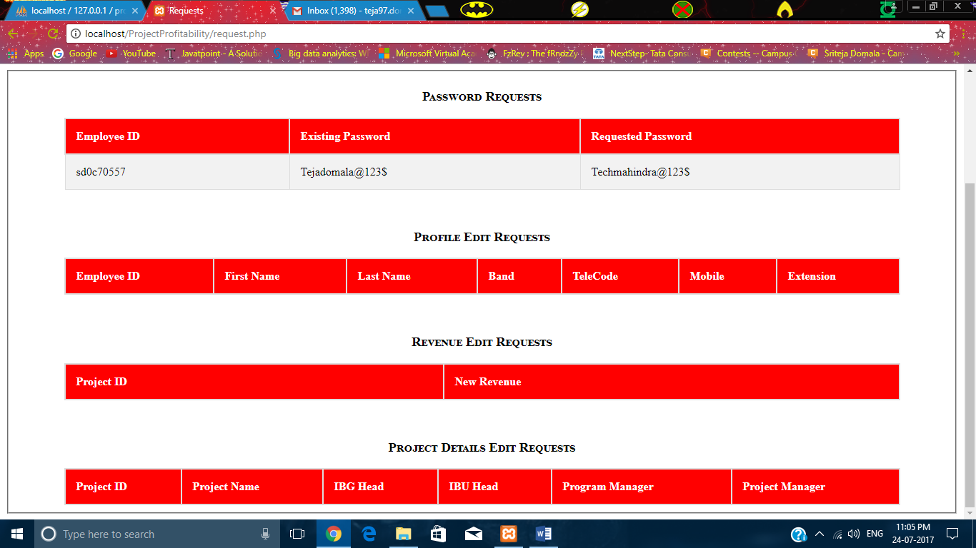**Fig: page that displays requests**

When the “**Requests**” link is clicked in the Admin’s dashboard, the above page appears. It contains the requests for Password change, profile edit, project revenue change and project details edit.

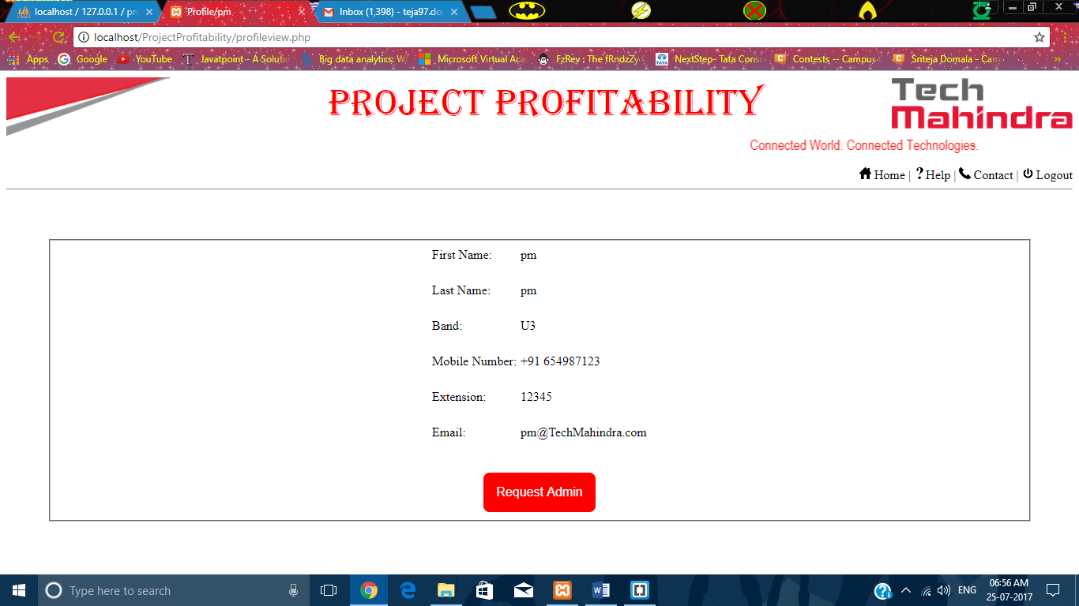**Fig: Page that shows user profile**

The above page is opened whenever a user clicks on the name that is after the “Welcome” line. It shows the details of the employee who is logged in currently. It has a button used to raise requests.

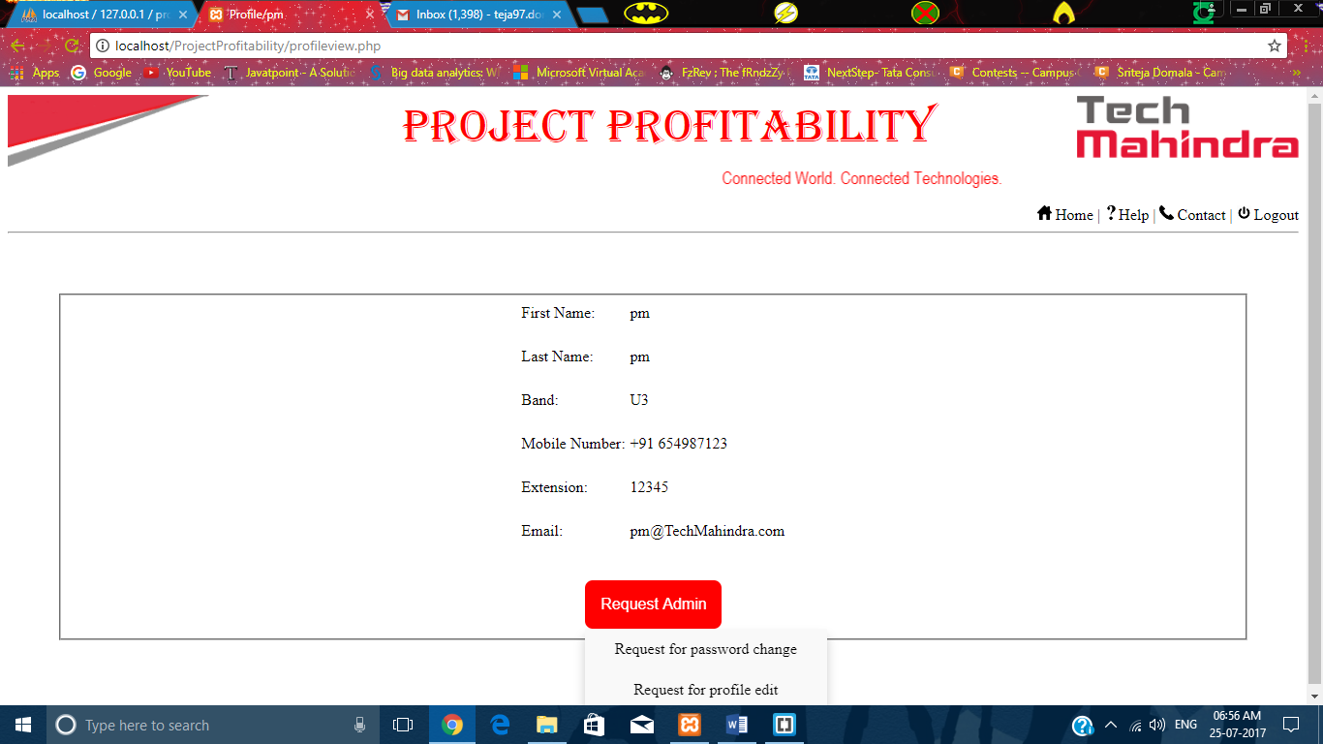**Fig: Page that shows user profile – Request Button**

In here, when the user draws the mouse over the “Request Admin” button, there will be few options. When a project manager logs in, only two options will be displayed – “Request for password change” and “Request for profile edit”.

But when a user other than Project Manager logs in, options displayed are “Request for password change”, “Request for profile edit”, “Request for revenue change” and “Request for change in project details”.

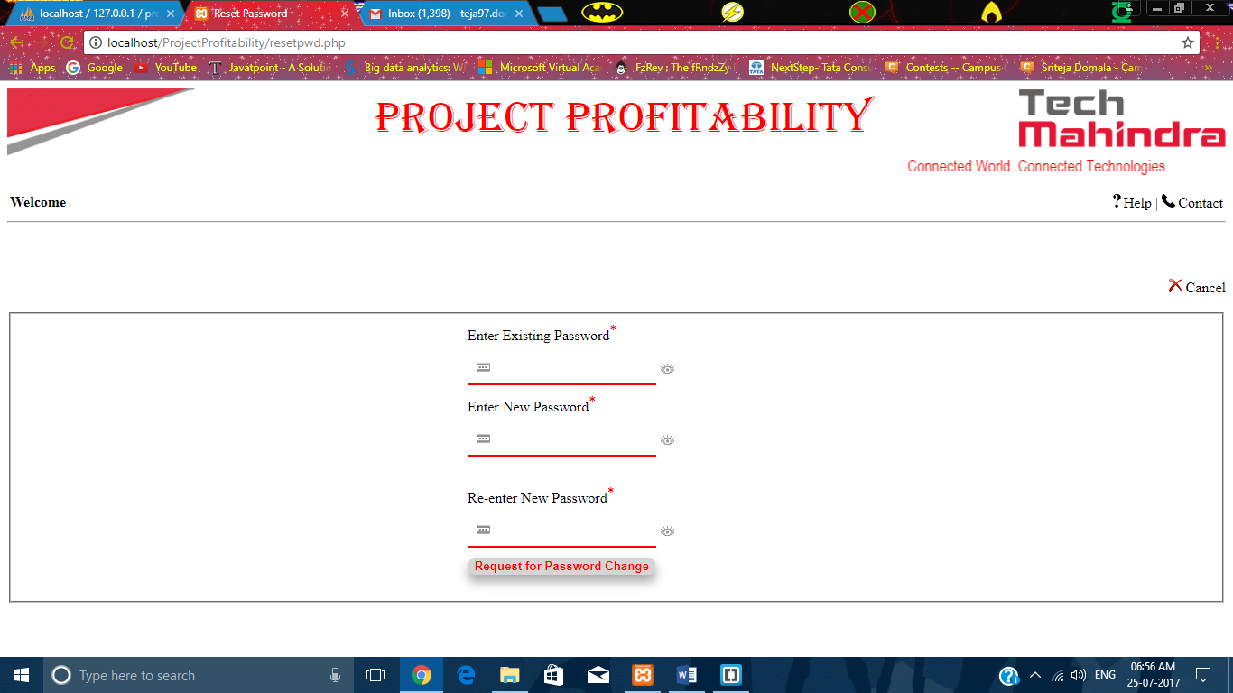**Fig: Page that is used to request for password change**

The above page is used to request for the change of user’s login password. It can be done by entering the Existing password, new password and re-entering the new password and then clicking the Request button. The cancel option cancels the requesting process.

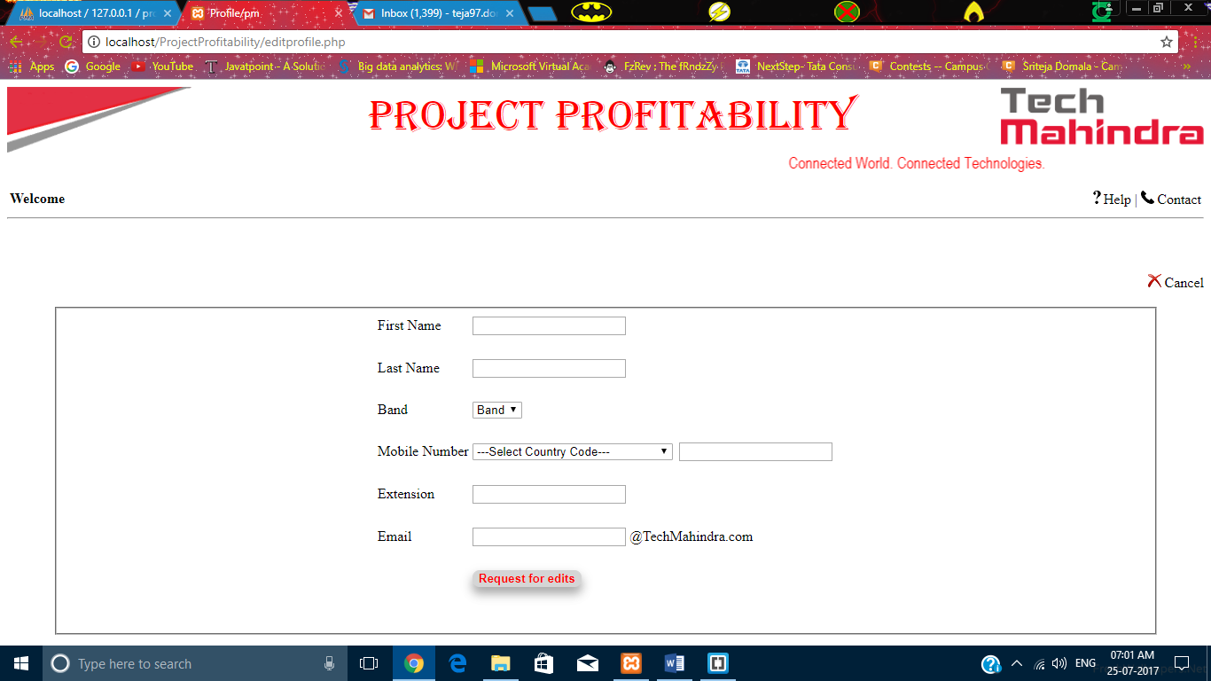

or strong so that accordingly he can change the password.



If the user enters the details correctly and then submits then alert will be displayed with a message shown.



If user proceeds with the same way as discussed above then he will be redirected to profile set page, where he need to enter the personal details like first and last name, band, mobile and extension.

After the profile is set it will automatically logout from that id and again login page will displayed



Dashboards Pages:

PM:  
When pm (project manager) logins then the user have only access to select the project and also he can see all the projects which are under him if he wants to search the project then he search the project by the project name.

In the projects he can check all the required details about the project like who are working for the project, head count for onsite and offshore (planned and actual), estimated and actual contribution. Where actually all the details will be entered either by the pgm or admin either it may be project details or any information regarding about the project.

If the project manager wants to checks the forecast page (resources page) he can select the project and then when he clicks on the submit button then it shows the resources page.

There are other options on the top (right side) like help, contact and logout button when userhave any doubt he can look at that options.



PGM:

When pgm logins then he have more projects under him and also project managers working under him for that purpose he is required to select the pm and project under to check the forecast page.



IBU:

When IBU logins then he have more projects under him and also PGM and PM working under him for that purpose he is required to select the PGM then PM and finally a project under to check the forecast page.



IBG:

When IBG logins then he have more projects under him and also IBU, PGM and PM working under him for that purpose he is required to select the IBU then PGM then PM and finally a project under to check the forecast page.

